**Test Field**

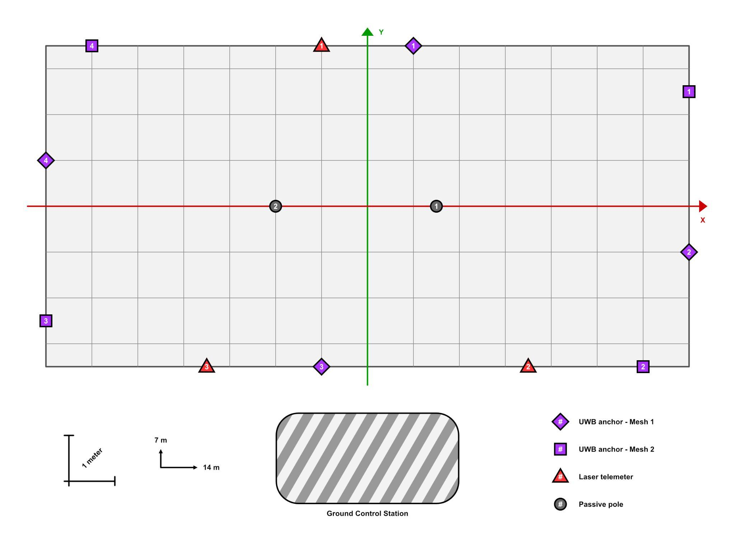

| **UWBs - Mesh 1** | **UWBs - Mesh 2** | **Laser telemeters** | **Passive poles** |
| --- | --- | --- | --- |
| | **n.** | **X** | **Y** | | --- | --- | --- | | 1 | 1.0 | 3.5 | | 2 | 7.0 | -1.0 | | 3 | -1.0 | -3.5 | | 4 | -7.0 | 1.0 | | | **n.** | **X** | **Y** | | --- | --- | --- | | 1 | 7.0 | 2.5 | | 2 | 6.0 | -3.5 | | 3 | -7.0 | -2.5 | | 4 | -6.0 | 3.5 | | | **n.** | **X** | **Y** | | --- | --- | --- | | 1 | -1.0 | 3.5 | | 2 | 3.5 | -3.5 | | 3 | 3.5 | -3.5 | | | **n.** | **X** | **Y** | | --- | --- | --- | | 1 | 1.5 | 0.0 | | 2 | -2.0 | 0.0 | |

**Notes**:

* Laser’s poles are NOT visible by the Lidar.
* The ground control station is NOT visible by the Lidar.
* All poles (excluding laser’s poles) are 2.10 m high
  + UWBs anchors are are placed at a height of 2.20 m

**Rover Informations**

* Rover wheel geometry:
  + Wheel-base: 1.08 m
  + Wheel-track: 1.29 m
  + Wheels radius: 0.20 m
* Uwb position:
  + Tag 1 (Front):,
    - forward of 1.16 m
    - height of 1.46 m
  + Tag 2 (Rear):
    - backward of 1.16 m
    - height of 1.48 m